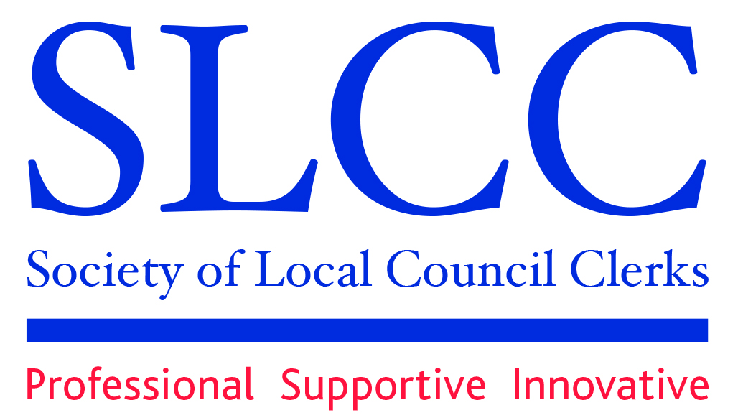
Rosie Smart, PSLCC
Branch Secretary
Northamptonshire Branch 83 Dowthorpe Hill
Earls Barton
Northampton
NN6 0PY
Tel: 01604 812850
E-Mail : theclerk.ebpc@gmail.com

THE AGM FOR SLCC NORTHANTS BRANCH WILL BE HELD ONLINE AT 7PM ON
MONDAY 22ND JULY 2024

THE LINK TO JOIN THE MEETING IS AS FOLLOWS:

Join the meeting now
Meeting ID: 357 545 853 203 4
Passcode: km2oJ6S2

AGENDA

- Welcome and introduction
- HOW TO BRING FRESH AIR TO TOXIC SITUATIONS – Talk by Becky Walsh
- To accept any APOLOGIES
- To sign and adopt the MINUTES of the AGM held on 22nd July 2024.
- To receive nominations and appoint a BRANCH CHAIRMAN for the year.
- To receive nominations and appoint a BRANCH TREASURER for the year.
- To receive nominations and appoint a BRANCH SECRETARY for the year.
- To receive nominations and appoint EXECUTIVE COMMITTEE MEMBERS for the year.
- To receive ANNUAL ACCOUNTS and the REPORT OF THE BRANCH TREASURER.
- To appoint branch mentors – 1 x North Northants, 1 x West Northants
- To receive the report of the SLCC NATIONAL FORUM.
- To receive ANY OTHER BUSINESS
- Q&A

Rosie Smart, PSLCC
BRANCH SECRETARY
18th September 2025

