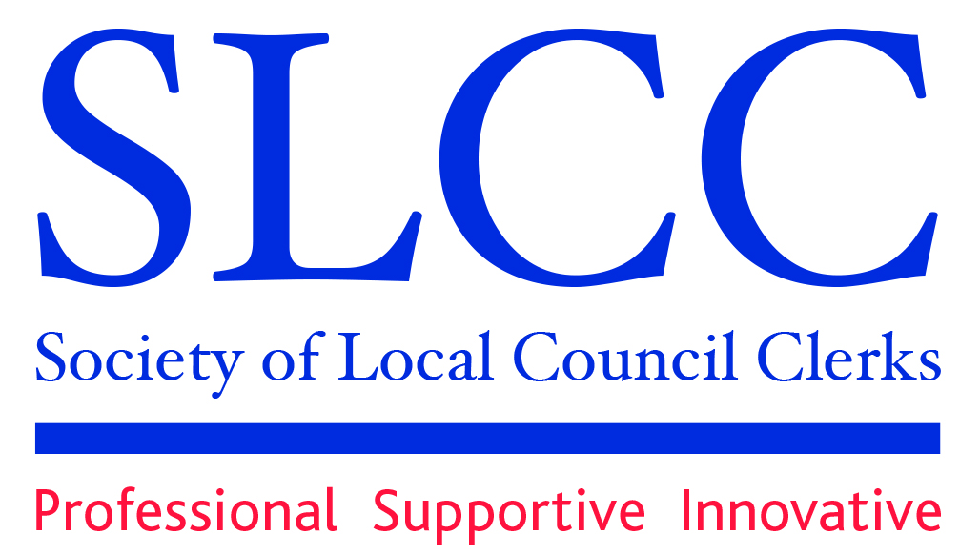

Northamptonshire Branch

MINUTES OF THE ANNUAL GENERAL MEETING OF THE SLCC NORTHANTS BRANCH HELD ONLINE ON MONDAY 22ND JULY 2024 AT 7.30PM

- 18 Member Clerks were WELCOMED to the meeting.
- APOLOGIES were received and approved from 6 member clerks.
- One nomination having been received, it was RESOLVED that Felicity Ryan be appointed CHAIRMAN for the year. Felicity thanked outgoing Chair, Linda Carter, for all her hard work on behalf of the branch and wished her well for the future.
- MINUTES of the 2023 AGM were adopted as a true record.
- One nomination having been received, it was RESOLVED that Sarah Rodgers be appointed TREASURER.
- One nomination having been received, it was RESOLVED that Rosie Smart be appointed SECRETARY for the year.
- Having been duly nominated, it was RESOLVED that Maggie Down, Jo Garner, Amy Holt, Mark Hunter, Paul Thomas and Sally Willis be appointed to the EXECUTIVE COMMITTEE for the year.
- TREASURERS REPORT – No report received. RS to contact SR for figures.
- BRANCH MENTOR REPORT – Sally McLellan was nominated mentor for the North Northants area and Paul Thomas was nominated mentors for the West Northants area.
- SLCC NATIONAL FORUM – it was RESOLVED that Mark Hunter be reappointed the Branch Representative on the National Forum, with Sally McLellan nominated as reserve. A report from Mark on the last National Forum meeting has been circulated to member clerks. Any points that the branch would like to raise with the National Forum should be forwarded to MH. PT asked for the lack of guidance around compassionate leave to be raised at the National Forum
- ANY OTHER BUSINESS – it was suggested that the branch look into training on ChatGPT. It was agreed that a questionnaire on training and branch activities be circulated to all member clerks.
- HOW AI IS GOING TO CHANGE YOUR JOB (AND YOUR LIFE!) – Danny Moody of Northants CALC headed a discussion on the use of AI in the town/parish council sector and how it can benefit councils. Notes for the presentation will be circulated separately.
- Q&A – Danny answered questions raised by those attending relating to AI.
- The DATE OF THE NEXT ANNUAL GENERAL MEETING to be confirmed.

All members attending were thanked and, there being no other business, the meeting was closed.

