  COUNCILLOR  DEVELOPMENT  FRAMEWORK  A practical workbook for  new and existing councillors |   Build confidence. Develop knowledge. Record progress.
  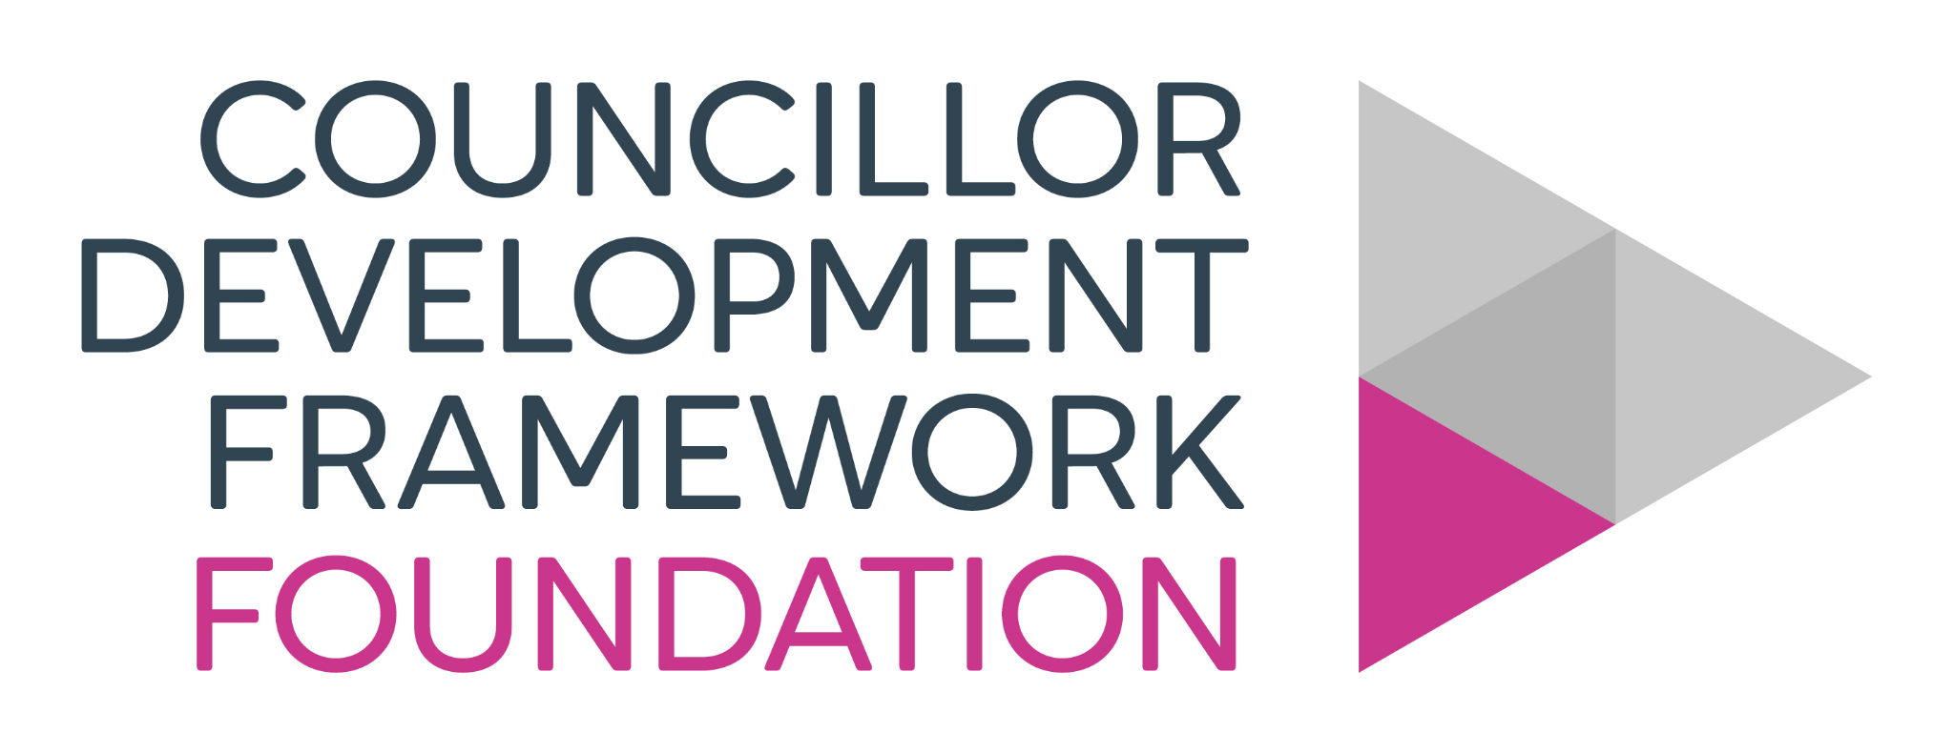 |  | 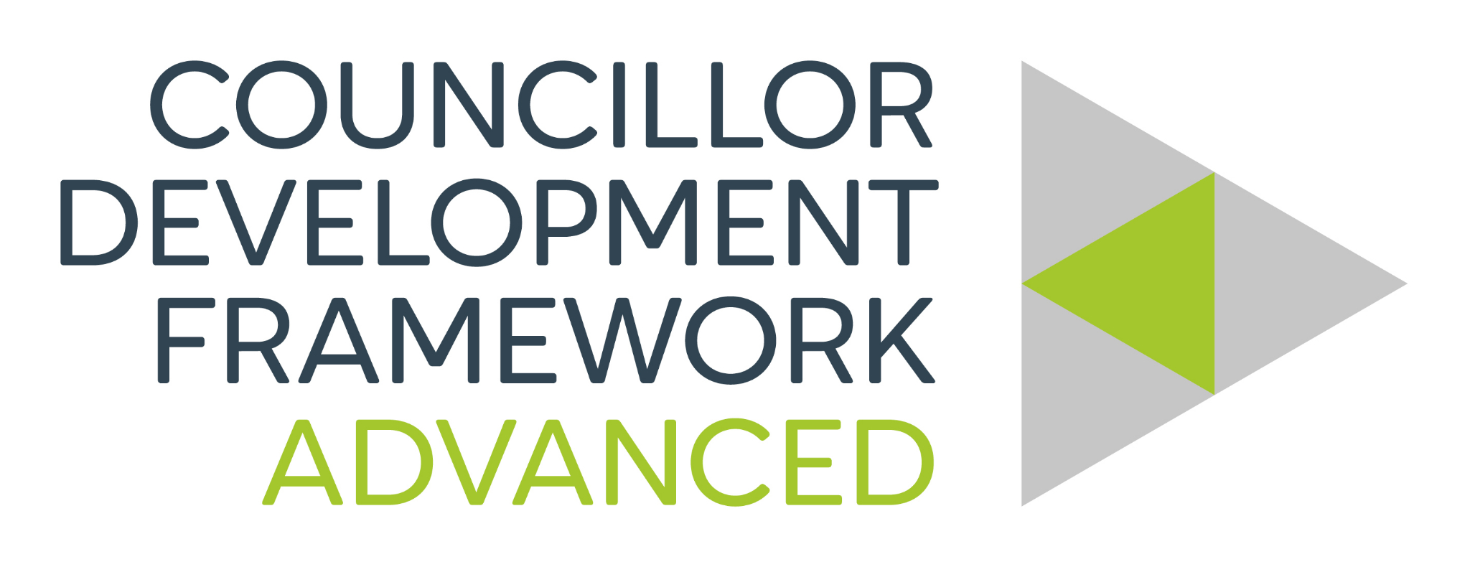 | 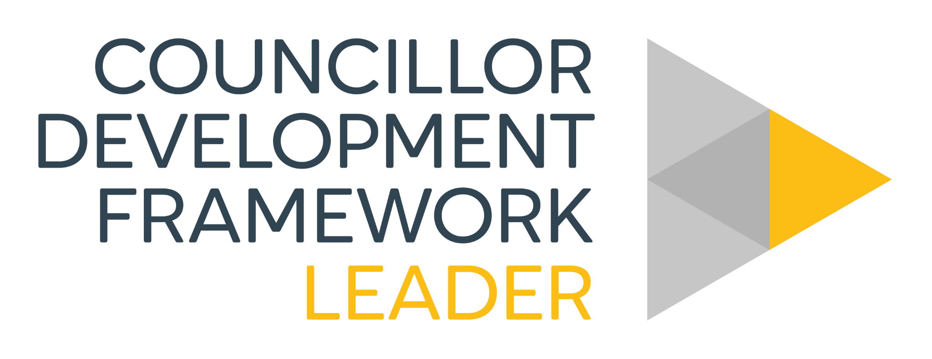

About my council

Complete the fields below. Use the drop-down arrows where a selection is available.
Electors  Click or tap here to enter text. | Current budget  Click or tap here to enter text. | Current precept  Click or tap here to enter text.
Band D rate  Click or tap here to enter text. | Council seats  Click or tap here to enter text. | Meeting frequency  Select an option
Unitary council  Select an option | Transparency code  Select an option | Police area  Select an option
Unitary ward(s)  Click or tap here to enter text. | Local MP(s)  Click or tap here to enter text. | Chair/Mayor and deputy  Click or tap here to enter text.
Council assets
☐ Burial ground | ☐ Village hall | ☐ Allotments | ☐ Playground | ☐ Streetlights

Foundation pathway and tracker

Required learning  - Off to a Flying Start  - Finance for Councillors  - The Code of Conduct in Practice  - The Good Councillors Guide (2024)  - The Good Councillors Guide to Finance and Transparency  - The Good Councillors Guide to Being a Good Employer  CLAIM FOUNDATION CERTIFICATE
  Activity | Date completed and notes
  • Off to a Flying Start | Click or tap here to enter text.
  • Finance for Councillors | Click or tap here to enter text.
  • The Code of Conduct in Practice | Click or tap here to enter text.
  • The Good Councillors Guide (2024) | Click or tap here to enter text.
  • The Good Councillors Guide to Finance and Transparency | Click or tap here to enter text.
  • The Good Councillors Guide to Being a Good Employer | Click or tap here to enter text.

Core pathway and tracker

Required learning  - Being a Good Employer  - Planning Nuts and Bolts  - The Good Councillors Guide to Cyber Security  - Equality and Diversity e-learning  CLAIM CORE CERTIFICATE
  Activity | Date completed and notes
  • Being a Good Employer | Click or tap here to enter text.
  • Planning Nuts and Bolts | Click or tap here to enter text.
  • The Good Councillors Guide to Cyber Security | Click or tap here to enter text.
  • Equality and Diversity e-learning | Click or tap here to enter text.

Leader pathway and tracker

Required learning  - Chairperson and Leadership  - Team Leadership Essentials e-learning  CLAIM LEADER CERTIFICATE
  Activity | Date completed and notes
  • Chairperson and Leadership | Click or tap here to enter text.
  • Team Leadership Essentials e-learning | Click or tap here to enter text.

Advanced pathways

Complete activities relevant to your role and council priorities.
Planning  • CIL and S106; Responding to Planning Applications | Community  • Communications; Social Media; engaging young people | HR  • Appraisals; staffing; grievance; recruitment
Finance  • Procurement; relevant year-end and VAT courses | Regulatory  • Data Protection; FOI; GDPR; Transparency Code | Other  • Trusts; emergency planning; civility; mapping
CLAIM ADVANCED CERTIFICATE

Advanced progress tracker

Record selected development activities, completion dates and notes.
Activity | Date completed and notes
Activity 1 | Click or tap here to enter text.
Activity 2 | Click or tap here to enter text.
Activity 3 | Click or tap here to enter text.
Activity 4 | Click or tap here to enter text.
Activity 5 | Click or tap here to enter text.
Activity 6 | Click or tap here to enter text.
Activity 7 | Click or tap here to enter text.
CLAIM ADVANCED CERTIFICATE

