Local Council Award Scheme application form
This document is a resource for Local Councils taking part in the Local Council Award Scheme
My council has not registered to take part in the scheme – this document is a useful tool to map where you do meet the criteria, and to help you see what work would need to take place before you apply
My council has the relevant criteria in place and has already registered with NALC – you can complete this document and submit it to your local accreditation panel. This will help them find the necessary information and make sure they don’t miss any details by mistake.
Tip – proving a web link to the exact page or document needed is important as it will reduce the risk of the panel missing any necessary information. So instead of http://www.nalc.gov.uk use http://www.nalc.gov.uk/our-work/improvement-and-development/local-council-award-scheme
Tip – some information and documents are not required to be published online. To keep things simple email these to the panel coordinator at the same time as providing this document. That way they have all the information in one place.
Tip – Don’t forget the read the full criteria in the Local Council Award Scheme guide. This form just has the summary, but there is further essential information in the guide which can be downloaded from http://www.nalc.gov.uk/our-work/improvement-and-development/local-council-award-scheme
What criteria do I need to meet for each award level?
If you are applying for Foundation – just the Foundation criteria
If you are applying for Quality – both Foundation and Quality criteria
If you are applying for Quality Gold – Foundation, Quality and Quality Gold criteria
If you are unsure what criteria you are required to submit please check with your County Association.

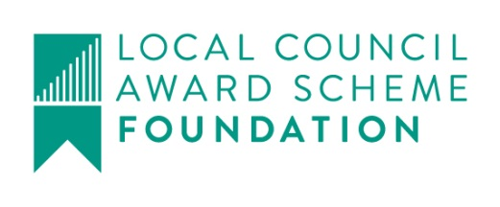
The Council confirms by resolution that all documentation and information is in place for a specified award | Does the council meet this requirement? | Hyperlink to council resolution:
Criteria | Do you meet these criteria? | Where are these published online?
- Its standing orders
- Its financial regulations
- Its Code of Conduct and a link to councillors’ registers of interests
- Its publication scheme
- Its last annual return
- Transparent information about council payments
- A calendar of all meetings including the annual meeting of electors
- Minutes for at least one year of full council meetings and (if relevant) all committee and sub-committee meetings
- Current agendas
- The budget and precept information for the current or next financial year
- Its complaints procedure
- Its accessibility statement
- Its privacy notice
- Council contact details and councillor information in line with the Transparency Code
- Its action plan for the current year
- Evidence of consulting the community
- Publicity advertising council activities
- Evidence of participating in town and country planning

The Council confirms by resolution that all documentation and information is in place for a specified award | Does the council meet this requirement? | Hyperlink to council resolution:
Criteria | Do you meet these criteria? | Where are these published? Can they be provided electronically?
- A risk management scheme
- A register of assets
- Contracts for all members of staff
- up-to-date insurance policies that mitigate risks to public money
- Disciplinary and grievance procedures
- A policy for training and training and development of and councillors
- A record of all training undertaken by staff and councillors in the last year
- A clerk who has achieved 12 CPD points in the last year

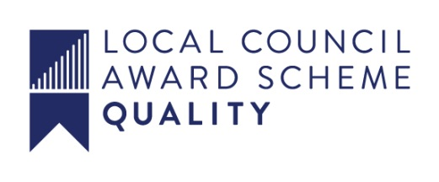
The Council confirms by resolution that all documentation and information is in place for a specified award | Does the council meet this requirement? | Hyperlink to council resolution:
Criteria | Do you meet these criteria? | Where are these published online?
- Draft minutes of all council and committee meetings within four weeks of the last meeting
- A Health and Safety policy
- Its policy on equality
- Councillor profiles
- A community engagement policy involving two-way communication between council and community
- A grant awarding policy
- Evidence showing how electors contribute to the Annual Parish or Town Meeting
- An action plan and related budget responding to community engagement and setting out a timetable for action and review
- Evidence of community engagement, council activities and the promotion of democratic processes in an annual report, online material and regular news bulletins
- Evidence of helping the community plan for its future

The Council confirms by resolution that all documentation and information is in place for a specified award | Does the council meet this requirement? | Hyperlink to council resolution:
Criteria | Do you meet these criteria? | Where are these published? Can they be provided electronically?
- a scheme of delegation (where relevant)
- at least two-thirds of its councillors who stood for election
- an annual report that is actively shared with the community
- Evidence of a customer service in how the council handles correspondence with the public
- a qualified clerk
- a formal appraisal process for all staff
- a training policy and record for all staff and councillors

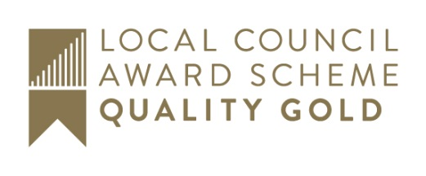
The Council confirms by resolution that all documentation and information is in place for a specified award | Does the council meet this requirement? | Hyperlink to council resolution:
Criteria | Do you meet these criteria? | Where are these published online?
- A business plan covering a financial forecast for at least three years linked to revenue and capital plans for the council and its community
- An annual report, online material, news bulletins and other council communications with evidence of
  - engaging with diverse groups in the community using a variety of methods
  - community engagement influencing council activity and priorities
  - A wide range of council activities, including innovative projects, that produce positive outcomes for the community
  - co-operating constructively with other organisations

The Council confirms by resolution that all documentation and information is in place for a specified award | Does the council meet this requirement? | Hyperlink to council resolution:
Criteria | Do you meet these criteria? | Have you provided these to the accreditation panel?
- Ensures that the council delivers value for money
- Provides leadership in planning for the future of the community
- Engages with the community on issues related to the environment and climate change
- Manages the performance of the council as a corporate body
- Manages the performance of each individual staff member to achieve its business plan

